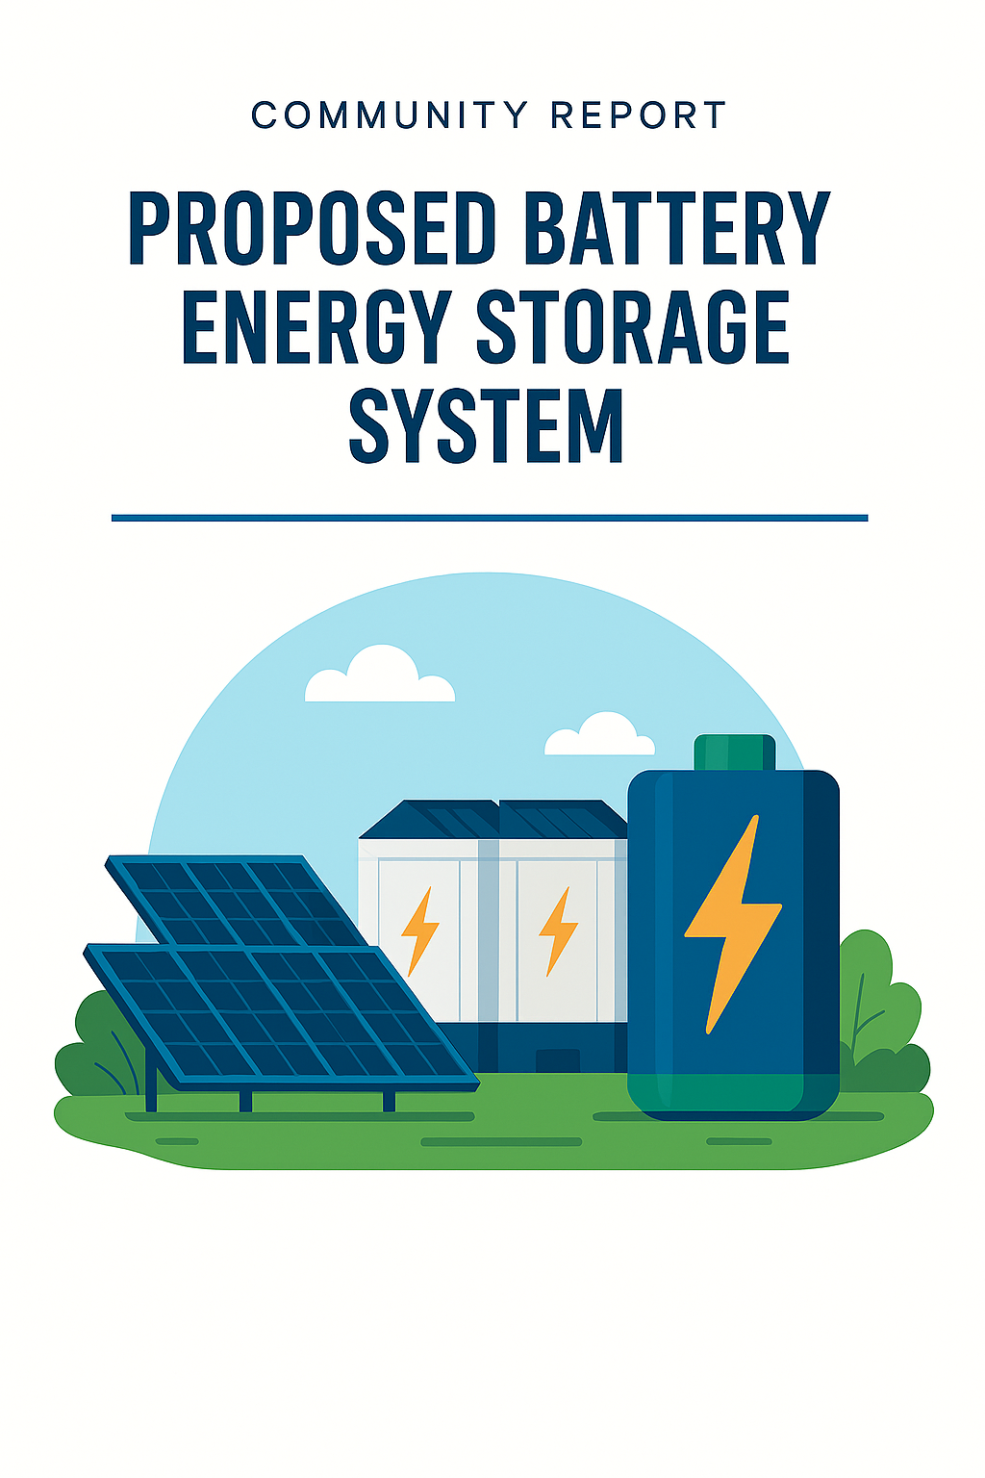
Community Concerns Report
Proposed Battery Energy Storage System (BESS) Near Goorambat, Victoria
Prepared from Community Consultation Feedback

Executive Summary
This report summarises the concerns, values, and recommendations raised by community members during a public meeting regarding the proposed large-scale Battery Energy Storage System (BESS) planned near the township of Goorambat.
The feedback demonstrates significant community concern regarding the proposed proximity of the battery installation to the township, perceived risks associated with fire, toxic emissions, environmental impacts, and the potential long-term transformation of the local rural landscape and lifestyle.
Community members expressed strong concerns that the project may negatively affect public safety, environmental health, property values, agricultural productivity, tourism, and future development opportunities for the town. There was also a clear sentiment that the current level of consultation and information provided has been insufficient to address community concerns.
At the same time, residents identified many highly valued characteristics of Goorambat that they believe require protection, including its farming heritage, tourism appeal, peaceful rural character, environmental assets, and strong community identity.
The community also identified several constructive actions and recommendations, including independent research, greater transparency, improved emergency planning, consultation with experts and government agencies, and investigation of alternative locations for the project.

1. Background
A community meeting was held to discuss the proposed Battery Energy Storage System (BESS) development near Goorambat. Residents, landholders, and community stakeholders were invited to identify:
- Key risks and concerns associated with the project;
- Important features and values of the Goorambat community;
- Potential actions and responses to address community concerns.
This report consolidates the feedback provided during the meeting for consideration by the project proponent and relevant authorities.

2. Major Community Risks and Concerns
2.1 Proximity to the Township
A major concern raised repeatedly by attendees was the proposed location of the battery system within approximately 800 metres of the township.
Residents expressed the view that:
- The project is too close to residential areas;
- Existing separation distances are inadequate for a facility of this scale;
- The close proximity increases perceived risks to residents, businesses, visitors, and agricultural operations.

2.2 Fire Risk and Emergency Response Capacity
Fire risk was identified as one of the most serious concerns.
Specific concerns included:
- Potential for battery thermal runaway events;
- Risk of prolonged and difficult-to-control fires;
- Lack of specialised local firefighting capability;
- Concerns that the local CFA may not have sufficient equipment, training, or resources to manage a large-scale battery fire;
- Potential for associated fires involving nearby solar infrastructure.
Residents expressed concern regarding:
- Emergency preparedness;
- Evacuation procedures;
- Availability of fire suppression systems;
- Containment measures;
- Responsibility for emergency management costs.

2.3 Toxic Smoke and Human Health Impacts
Community members raised concerns regarding potential toxic emissions resulting from battery fires or failures.
Concerns included:
- Toxic smoke exposure;
- Respiratory health impacts;
- Airborne contamination;
- Potential impacts on vulnerable residents;
- Risks to livestock and wildlife.
Some attendees also expressed concerns regarding possible long-term contamination and perceived radiation risks.

2.4 Noise Impacts
Noise generated by the battery facility was identified as another major issue.
Residents expressed concerns about:
- Continuous operational noise;
- Sleep disturbance;
- Mental stress and reduced wellbeing;
- Loss of rural amenity and serenity;
- Potential impacts on livestock behaviour and wildlife.
There were concerns that ongoing industrial noise would fundamentally alter the character of the township.

2.5 Environmental Concerns
Significant concern was expressed regarding environmental contamination risks.
Key issues raised included:
- Toxic runoff entering waterways and dams;
- Potential impacts on underground water systems;
- Risks to Broken Creek;
- Potential contamination affecting livestock and agricultural production;
- Impacts on local wildlife, including platypus and birdlife.
Residents requested greater transparency regarding:
- Water management plans;
- Spill containment;
- Environmental monitoring;
- Long-term remediation responsibilities.

2.6 Agricultural and Economic Impacts
Residents highlighted concerns about impacts on farming operations and regional productivity.
Concerns included:
- Reduced farming capacity;
- Impacts on food production and food security;
- Increased insurance costs for neighbouring landholders;
- Reduced attractiveness for agricultural investment.

Community members also raised concerns regarding:
- Potential devaluation of property prices;
- Reduced tourism visitation;
- Negative impacts on local businesses.

2.7 Impact on Community Identity and Future Development
Residents expressed concern that the project may contribute to further industrialisation of the district.
Specific concerns included:
- Expansion of renewable energy infrastructure in the area;
- Increased likelihood of additional solar or battery developments;
- Impacts on future town growth and development;
- Loss of rural character and landscape values.
Some attendees stated concerns that the township could increasingly become perceived as an industrial energy zone rather than a rural community.

2.8 End-of-Life and Long-Term Responsibility
Community members questioned:
- What would occur at the end of the project life;
- How batteries would be decommissioned and disposed of;
- Who would carry long-term environmental and financial responsibility;
- Whether rehabilitation guarantees would be in place.

3. Valued Features of Goorambat
Participants identified many features that contribute to the uniqueness and value of Goorambat and which they believe should be protected.
These included:
Community and Lifestyle
- Strong community spirit;
- Peaceful and quiet rural lifestyle;
- Low traffic volumes;
- Clean air and natural environment;
- Rural ambience and scenic landscape.
Agriculture and Heritage
- Generational farming history;
- Productive agricultural land;
- Contribution to food production and food security;
- Historic buildings and heritage character.
Tourism and Local Economy
- Tourism appeal;
- Silo art and church mural attractions;
- Local businesses including the bakery and post office;
- Sporting clubs including football and netball.
Natural Environment
- Wildlife and biodiversity;
- Platypus habitat;
- Birdlife and creek systems.
Location Advantages
- Proximity to Benalla and regional services while maintaining a rural lifestyle.
4. Community Suggestions and Recommended Actions
Community members proposed a range of actions aimed at improving understanding of the project and protecting community interests.
4.1 Independent Research and Expert Advice
Residents requested:
- Independent technical research;
- Funding support for independent studies;
- Access to accurate data regarding battery fire incidents and risks;
- Legal and environmental expertise.

4.2 Emergency Management and Fire Response
Suggestions included:
- Dedicated specialist firefighting capability funded by the project proponent;
- Consideration of 24/7 emergency response resources;
- Detailed emergency management planning and public communication.

4.3 Environmental and Waterway Assessment
Residents requested:
- Investigation of potential impacts on waterways and groundwater;
- Consultation with Goulburn-Murray Water;
- Environmental monitoring and containment planning.

4.4 Community Consultation and Transparency
Attendees expressed a strong desire for:
- Improved consultation processes;
- Greater transparency regarding project risks;
- Opportunities for meaningful community input into project design and scope;
- Clear communication regarding approvals and planning processes.

4.5 Engagement with Other Communities and Stakeholders
Suggestions included:
- Consulting with communities already located near battery facilities;
- Seeking input from Yorta Yorta Nation Aboriginal Corporation;
- Collaborating with neighbouring communities and groups, including Dookie, Glenrowan and Winton.

4.6 Political and Community Advocacy
Community members proposed:
- Petitions;
- Letters and submissions to local government and state agencies;
- Engagement with media outlets and social media;
- Lobbying elected representatives regarding Renewable Energy Zone (REZ) planning and policy.

4.7 Investigation of Alternative Sites
Residents requested that alternative locations for the battery project be explored, particularly sites further from townships and sensitive agricultural land.

5. Conclusion
The feedback collected during the community meeting demonstrates substantial concern regarding the proposed Battery Energy Storage System near Goorambat.
The key themes emerging from the consultation include:
- Safety and emergency response capability;
- Health and environmental risks;
- Protection of agricultural productivity;
- Preservation of community identity and rural amenity;
- Concerns regarding consultation, transparency, and long-term accountability.
The community has clearly articulated that Goorambat’s rural character, environmental assets, agricultural productivity, tourism appeal, and strong social fabric are highly valued and should be carefully considered in any future planning and decision-making processes.
Residents are seeking genuine engagement, independent assessment of risks, and meaningful opportunities to influence the planning and design of the project moving forward.

