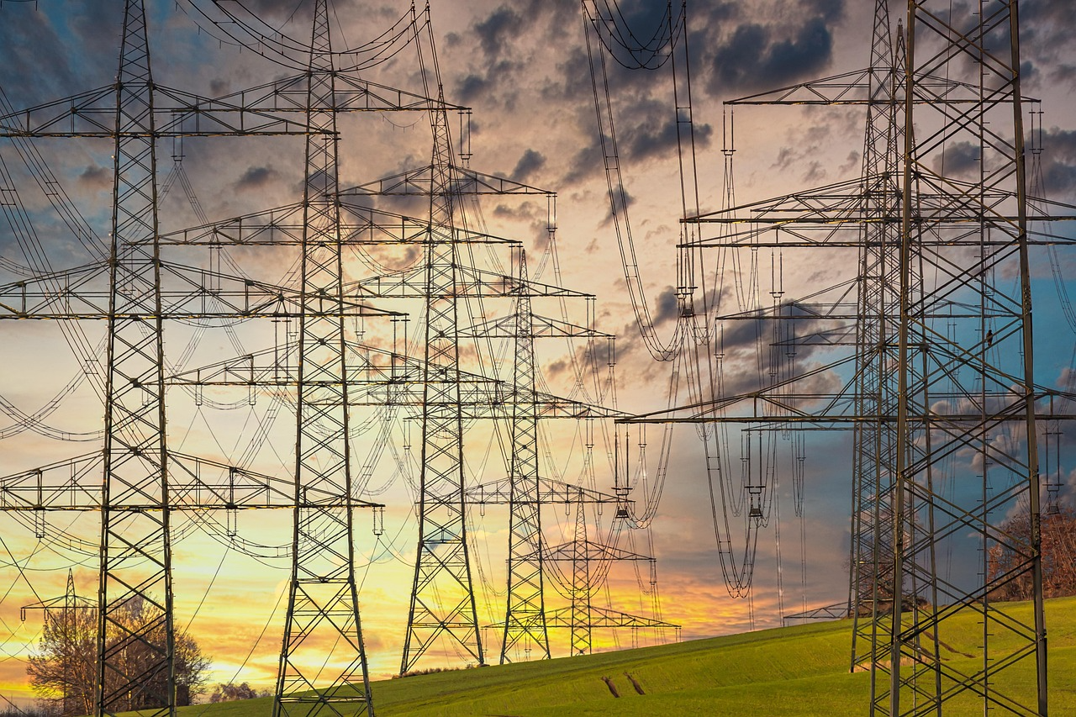

Vicgrid
Vicgrid is a Victorian government entity setup to try and regulate the implementation of renewable energy zones. This entity has been setup post after a number of projects have already been given planning permits and or are already completed.
“The horse has already bolted”.
This entity should have been setup some years ago. Vicgrid are still working through their terms of references and also what function they will play in the renewable energy zone in the area of regulation, community consultation and enforcement of regulations and governance.

REZ
As a result of the creation of Vicgrid one of its first tasks along with the Victorian Government was to create a Renewable Energy Zone. Information can be obtained at the Vicgrid website with regards to the Renewable Energy Zone.
Many of the communities along the REZ have felt that this was done with no consultation, no feedback and the easiest path was to place the zone near existing high voltage power lines. In a discussion with Alistair Parker at Goorambat we have received conflicting reports, advice with regards to the overall plan when compared to other areas, i.e. The Protect Dookie & the Goulburn Valley meetings.
While Renewable Energy Zones (REZs) are designed to coordinate transmission and scale, developers are actively proposing and building numerous solar, wind, and storage projects outside these zones.
In Victoria, 70% of approved renewable energy projects are located outside the declared REZ areas. (Reported in The Weekly Times on the 10th of June 2026)
State Funding Mechanisms: Initiatives like Victoria’s State Electricity Commission (SEC) and the federal Capacity Investment Scheme (CIS) are actively backing projects, including standalone big batteries, that are not strictly confined to REZs.

